Physics lab 5

1 Theory
Mechanical energy is the sum of the potential and kinetic energies in a system. The principle of the conservation of mechanical energy states that the total mechanical energy in a system (i.e., the sum of the potential plus kinetic energies) remains constant as long as the only forces acting are conservative forces. Normally, all forces acting on our system are conservative as long as there is no friction.
1.1 Types of mechanical energy
In mechanics problems, we are likely to encounter systems containing kinetic energy KE = 1mV 2 , (1)
2 where m is the mass of our object and V is its speed (disregarding of the direction). Generally speaking,
the kinetic energy is the energy of the motion and it disappears if the speed of our object is zero. We will also often encounter gravitational potential energy
PEg =mgh, (2)
where h is the elevation of our object from a fixed zero level. Only the vertical component, or the height of our object contributed to its gravitational potential energy, not its horizontal position.
We might also need to account for the elastic—spring—potential energy of a compressed or stretched spring with spring constant k
PEs = 1kx2 , (3) 2
where x is the displacement of the end of the spring from its equilibrium position.
There might be a few other exotic types of potential energy, such as the energy of an electromagnetic field, or the potential energy due to a buoyant forces if such fields and forces are present, which will not be the case for our lab.
1
1.2 Conservation of the mechanical energy
As we mentioned above, the mechanical energy is conserved if the friction forces acting on our system are negligible. Let us consider a cart moving along a frictionless track, as shown at Fig. 1
Figure 1: Conservation of mechanical energy (potential + kinetic) on a track. The bar charts show the amount of the potential and kinetic energies in di↵erent points of the track.
Its potential energy PE = mgh depends only on its vertical position h along the track. If the total energy is conserved
PE(h)+KE(v)=Etot =const, (4) the kinetic of the cart could be found as
KE = Etot mgh , (5) where the total energy of the cart is equal to its potential energy at the highest point, where the cart
is not moving and, therefore, its kinetic energy is zero Etot = P E(hmax) = mghmax . (6)
Once the kinetic energy KE of our cart is known, its speed could be found from the definition of kinetic energy (1) as
V = r2KE . (7) m
If the energy is conserved, the potential energy is transferred to the kinetic and back so that the potential energy in the lowest point of the track is zero, and the total energy is equal to the potential one. If the friction force is present, the work of friction is negative and proportional to the distance which
our cart has traveled along the track
Wf = fdcos⇡ = fd, (8)
where f is the friction force. The total energy keeps constantly decreasing while our cart is moving along the track until it comes to a full stop.
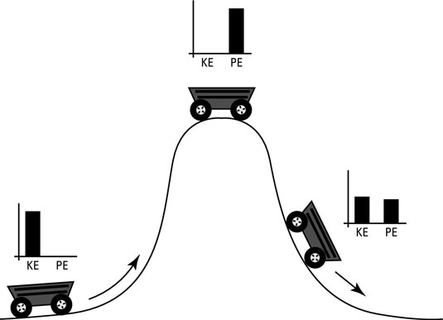
2
2 2.1
2.2
Useful resources Educational websites
https://www.siyavula.com/read/science/grade-10/mechanical-energy/22-mechanical-energy-05 https://en.wikipedia.org/wiki/Conservation_of_energy https://cnx.org/contents/MymQBhVV@175.5:N-ly1_0_@2/Conservation-of-mechanical-energy
YouTube videos
https://www.youtube.com/watch?v=AnuLW0ZX7-Q https://www.youtube.com/watch?v=hce4pncZlI4&t=445s https://www.youtube.com/watch?v=AzXb63GEMss

and many-many others available online.
3 Procedure
1. Open our present online lab by clicking on
https://phet.colorado.edu/sims/html/energy-skate-park-basics/latest/energy-skate-park-ba en.html.
Choose Intro window on the left. Now, your screen should look in the following way
Figure 2: (Color online) To be used for Step 1.
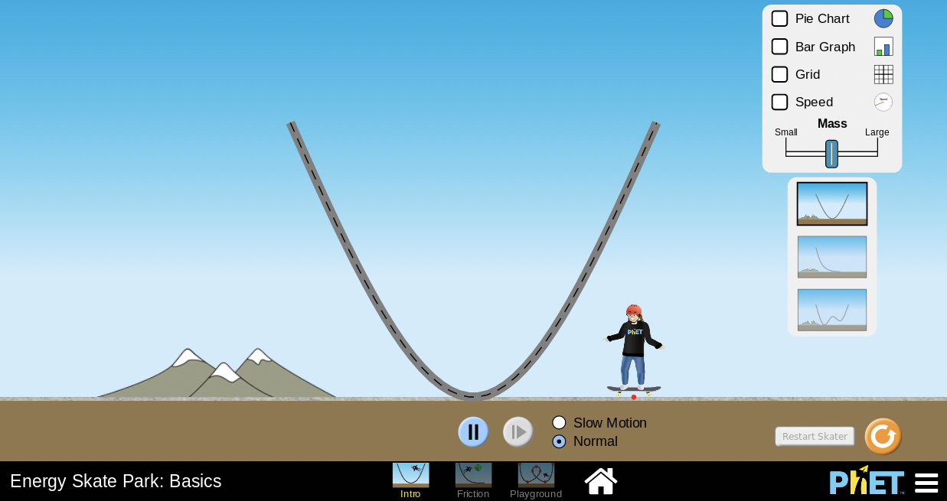
3
s
- You should see a skater standing on the ground next to the track. To begin our experiment, drag the skater onto the top left part of the track and release him. The skater will demonstrate periodic motion along the track, up and down, and so forth.
- Make your prediction for the following How does the potential energy PE(h) and kinetic energy KE(h) change from the highest to the lowest point of the skater’s trajectory?
- Enable all the checkmarks Pie Chart, Bar Chart, Grid and Speed ( , and )in the top right corner of your screen, which will now look as Figure 3: (Color online) To be used for Step 4.
- Based on your observation, answer the following questions: How does mechanical energy change with time? How you determine the kinetic energy KE?
- Consider the mass of a skater to be m1 = 30 kg, calculate its potential energy at h = 6 m, 5 m, 4 m, 3m, 2m 1m and 0 using Eq. 2. Record your results in Table 1 Table 1. Potential energy of the skater as a function of his/her height on the track.
- Using Eq. (6), calculate the total energy of the skater equal to their potential energy at the initial point with h = 6 m.
- 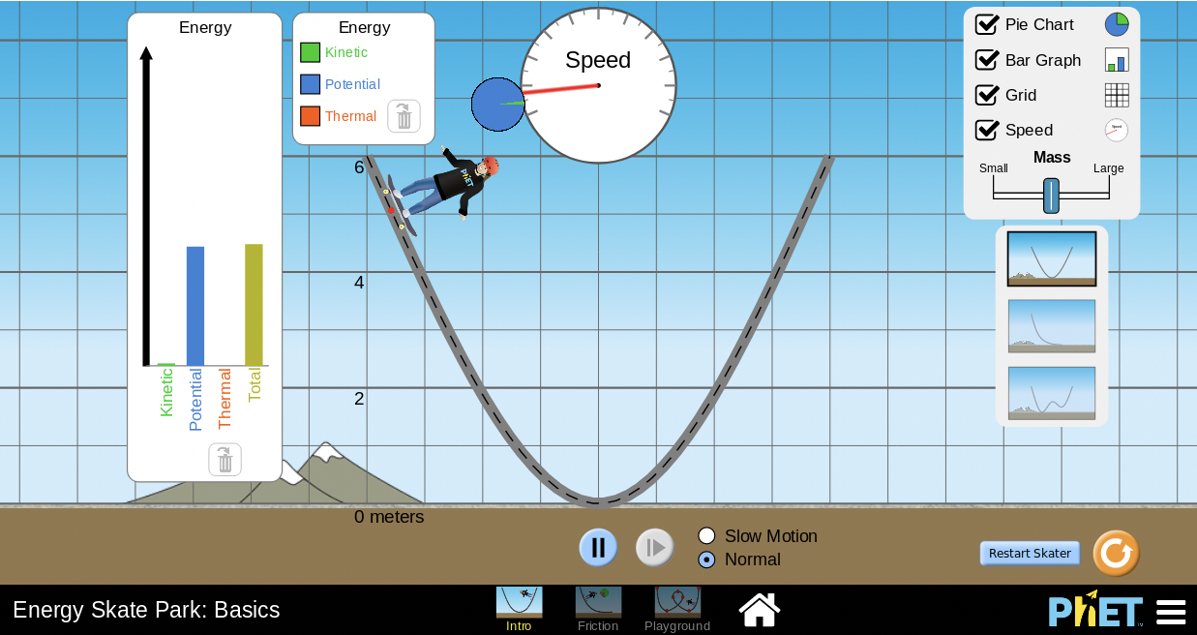
Height h, m | 6 | 5 | 4 | 3 | 2 | 1 | 0
PE(h), J
4
- Based on the conservation of mechanical energy expressed in Eq. (5), calculate the kinetic energy of the skater at points h = 6m, 5m, 4m, 3m, 2m 1m and 0. Calculate the speed of the skater from its known kinetic energy KE by Eq. 7. Add your results to Table 2 Table 2. Kinetic energy and velocity of the skater as a function of his/her height on the track.
- Based on the date from Table 2, prepare a graph for the kinetic energy KE for the skater at various positions. Make sure it is large and legible.
- Press Restart skater button in the lower right corner of your screen to release them from their initial position. Use the Mass slider on the right to choose a relatively small (close the the left margin) mass of the skater. Use the speedometer to experimentally determine the speed of the skater at the previously considered positions. Add your results to Table 3 Table 3. Experimentally determined speed of the skater as a function of his/her height on the track.
- Compare your theoretical results for the skater’s speed obtained in Step 8 with the corresponding experimental data from the previous Step 10. For three points with h = 5m, h = 3m and h = 2m, calculate the percent error as %error=2|Vexp V| ·100%. (9) Vexp + V
- Choose a larger value of mass of the skater as m2 = 75 kg and repeat all your theoretical Steps 6-9. Choose a larger mass of a skater by moving the Mass slider to the right and repeat your experimental Step 10 and analysis in Step 11.
- Next, choose the bottom track at the lower right part of your screen and repeat Steps 6-12 at the six points indicated in Fig. 4. Obtain the potential, kinetic and the total energies, as well as the speeds.
Height h, m | 6 | 5 | 4 | 3 | 2 | 1 | 0
KE, J
V , m/s
- 
Height h, m | 6 | 5 | 4 | 3 | 2 | 1 | 0
Vexp, m/s
5
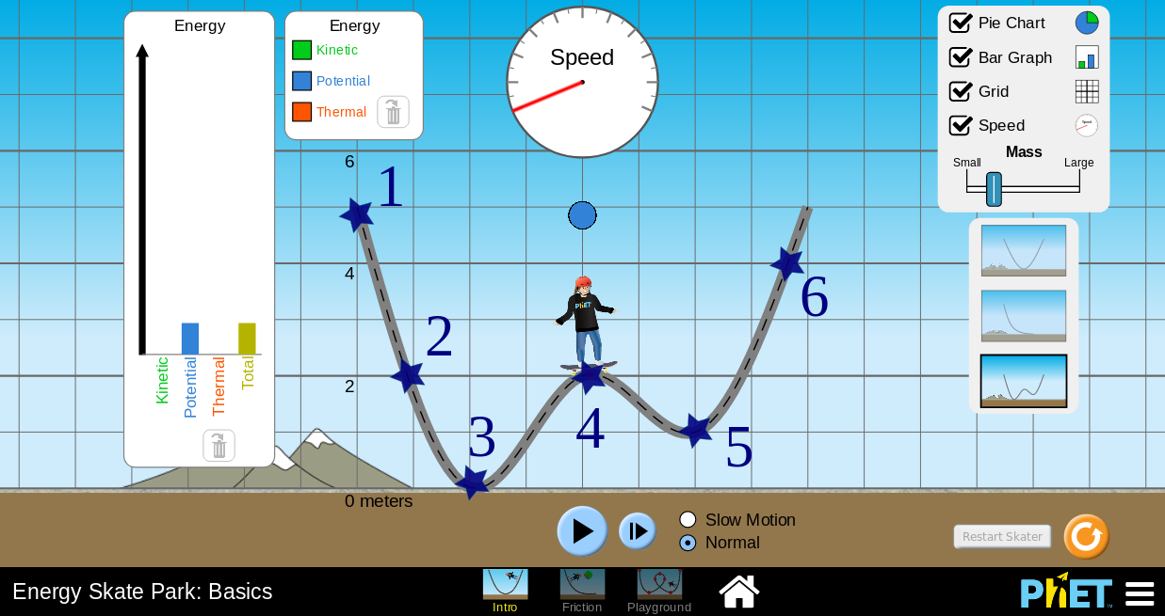
Figure 4: To be used for Step 13. Important. Please use the proper values of the coordinates for the points indicated in Fig. 4 for
calculating the potential, kinetic and the total energies.

